Rumah Sakit Umum Daerah

ce97bacbfafd14b4f720a4e192ccf51f-removebg-preview.pngce97bacbfafd14b4f720a4e192ccf51f-removebg-preview.png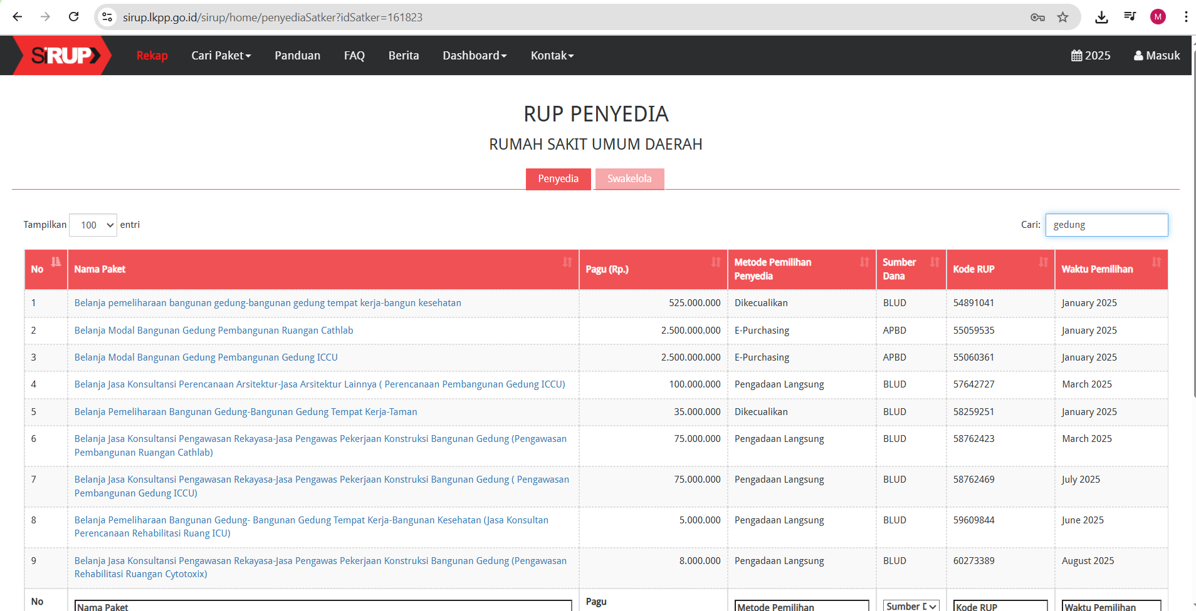

ce97bacbfafd14b4f720a4e192ccf51f-removebg-preview.png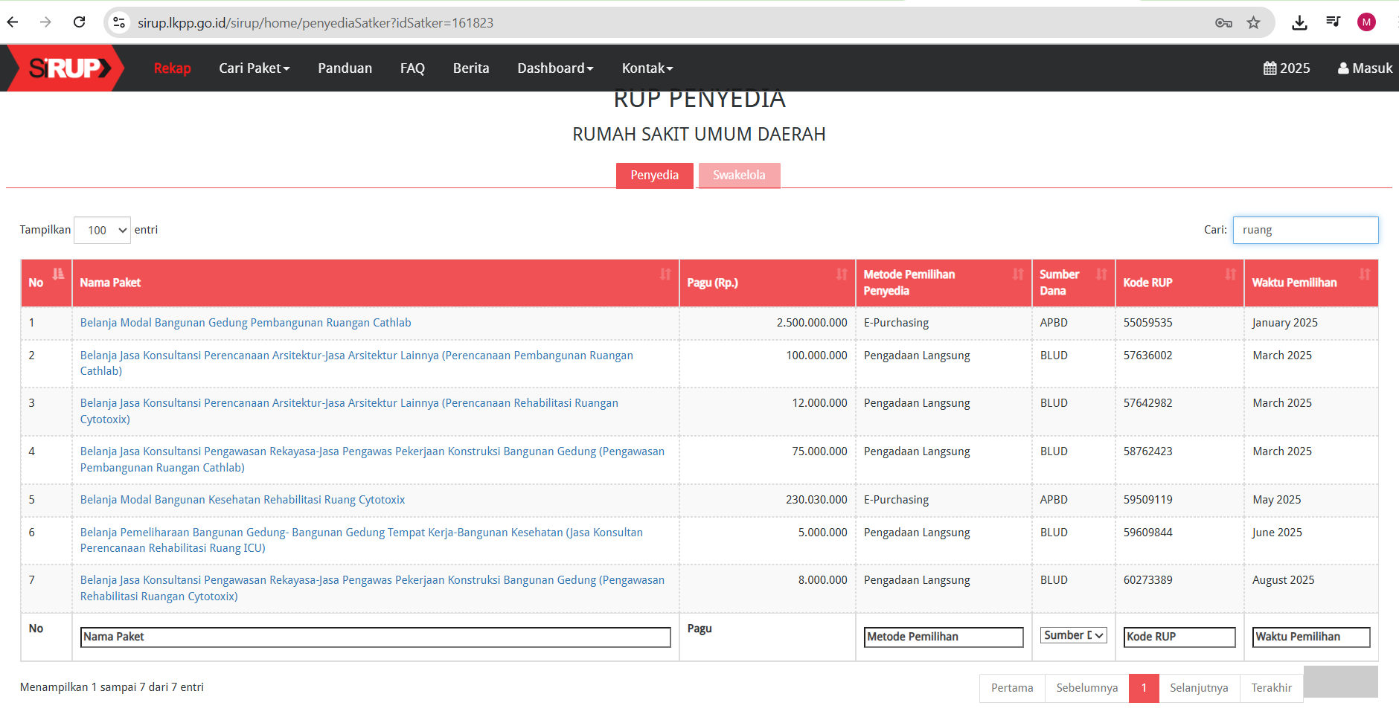

Dinas Pekerjaan Umum dan Penataan Ruang

ce97bacbfafd14b4f720a4e192ccf51f-removebg-preview.pngce97bacbfafd14b4f720a4e192ccf51f-removebg-preview.png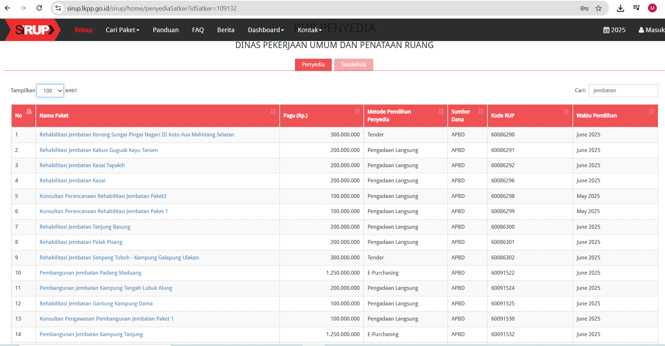

ce97bacbfafd14b4f720a4e192ccf51f-removebg-preview.png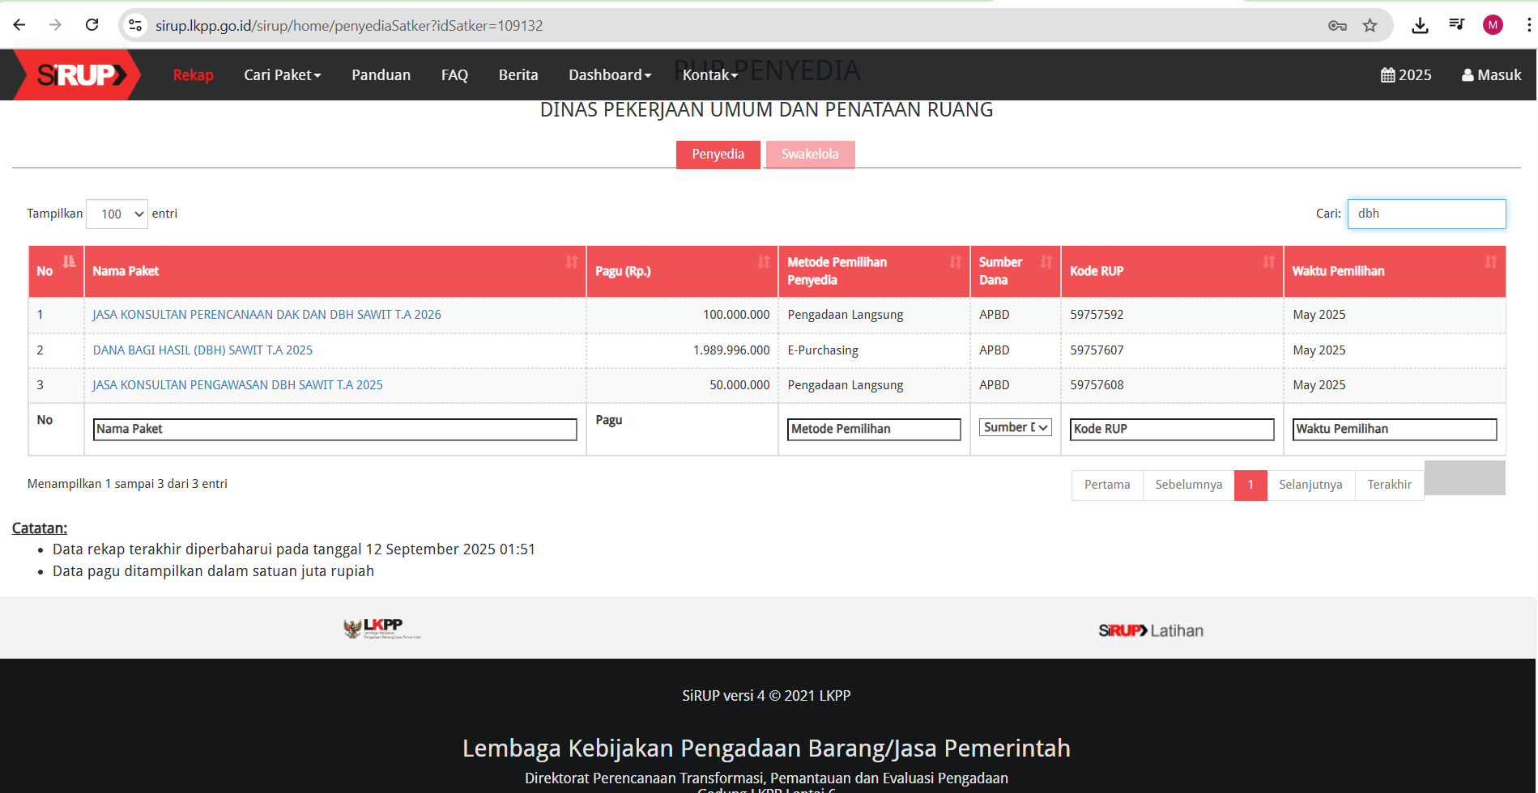

ce97bacbfafd14b4f720a4e192ccf51f-removebg-preview.png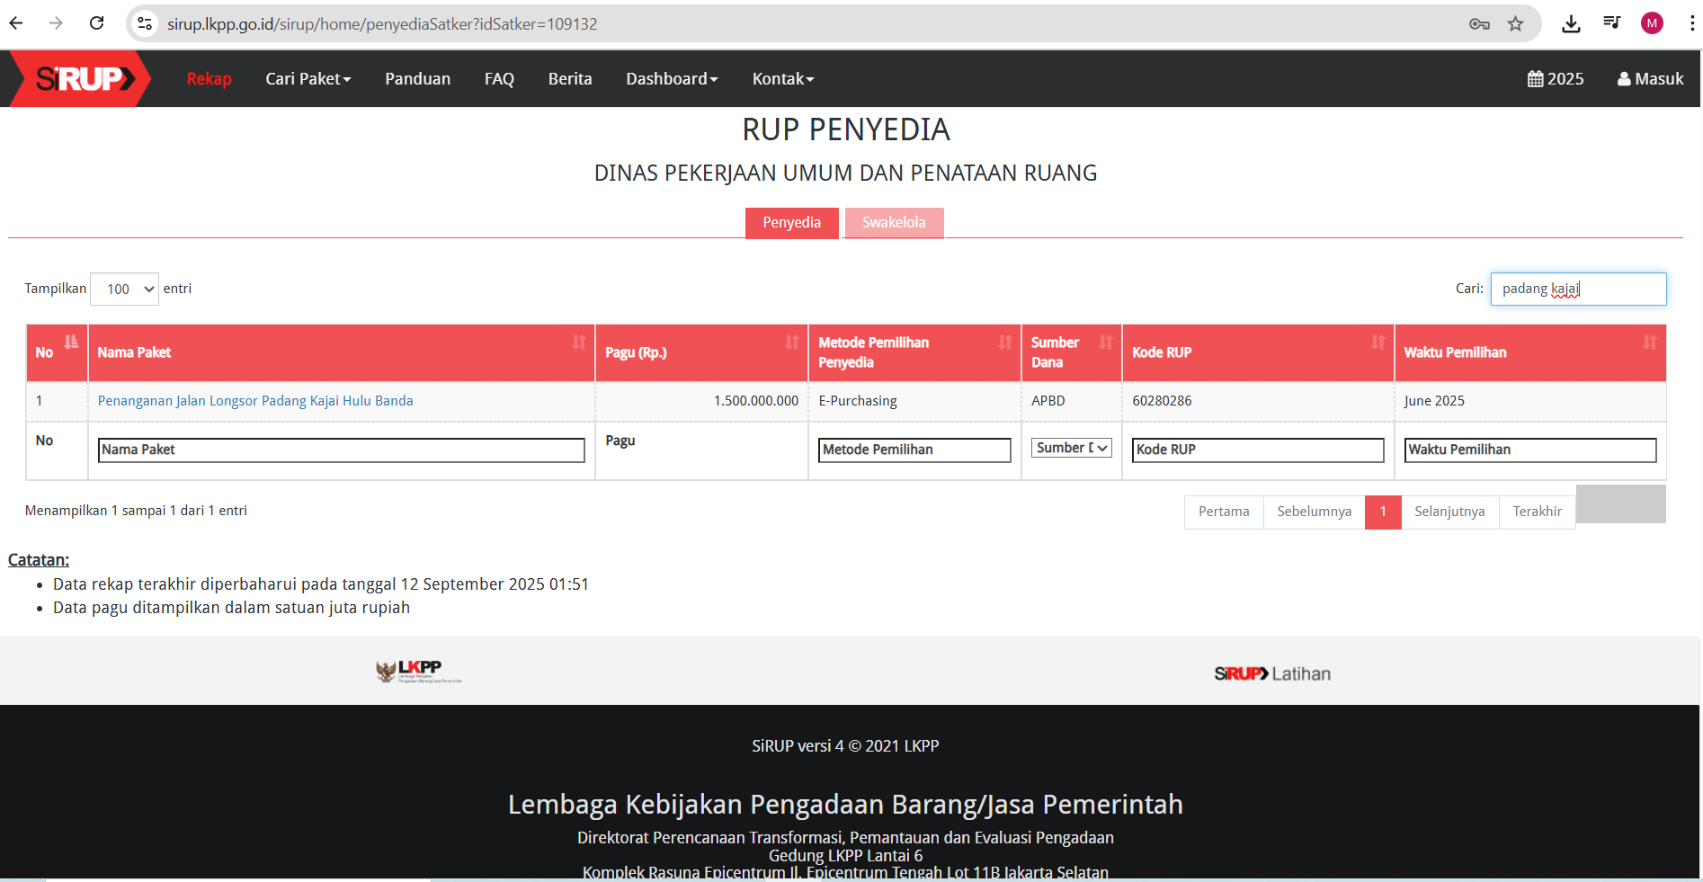

ce97bacbfafd14b4f720a4e192ccf51f-removebg-preview.pngce97bacbfafd14b4f720a4e192ccf51f-removebg-preview.png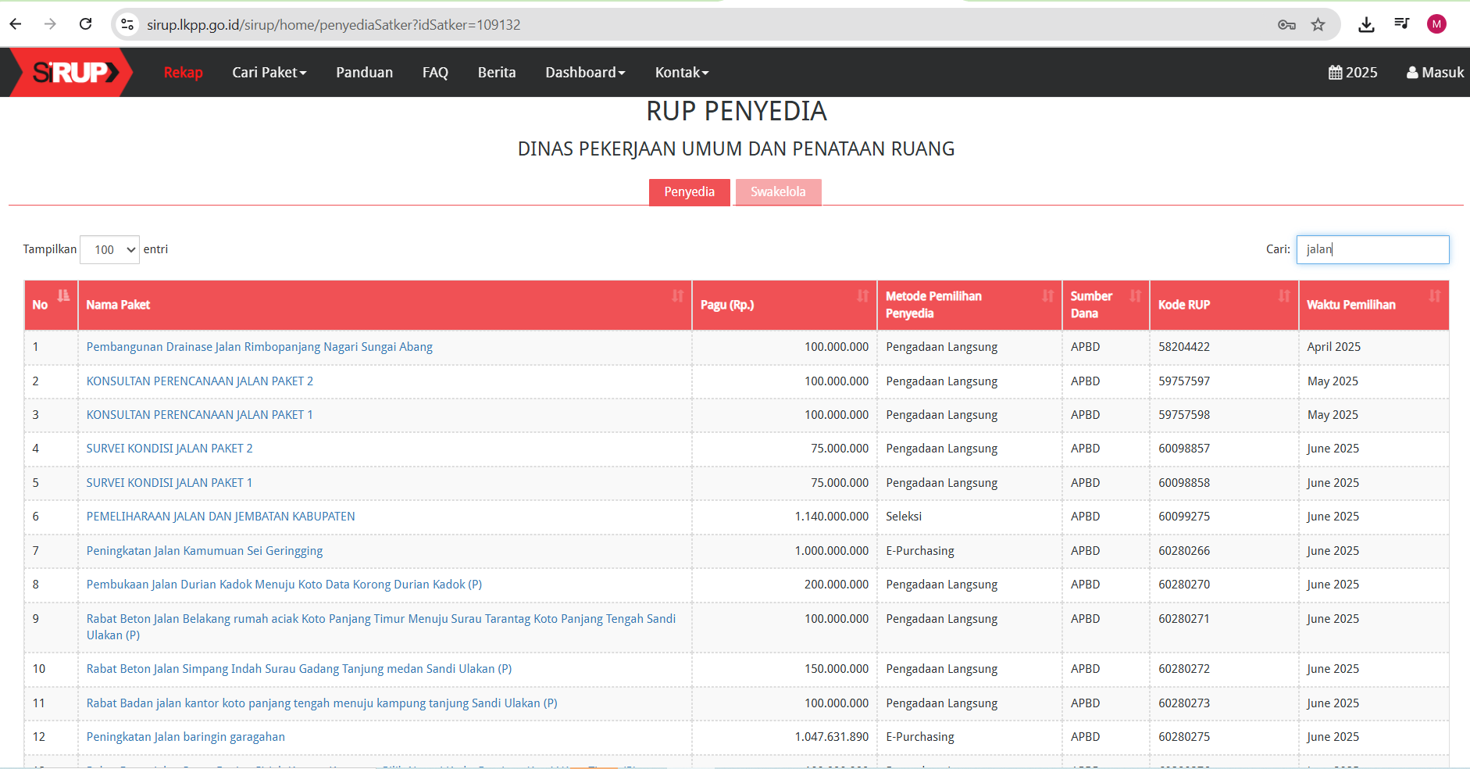

ce97bacbfafd14b4f720a4e192ccf51f-removebg-preview.png